

EGH446 INS Lab 3

Prepared by: Abdul Amir Bin Zakaria

8927871

Date: 15/05/2017

Signature:

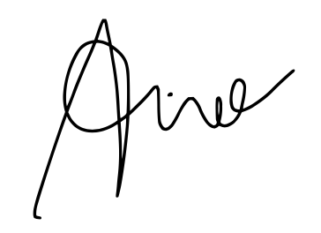

# **Observations and Comments**

**3. Correct the following in the angular propagation code:**

**• The earth rate should be the earth rate corresponding to the current position. Refer to [1] for earth rate calculations.**

**• The transport rate should be calculated on the basis of the current velocity. Refer to [1] for transport rate calculations.**

**4. Correct the following in the linear propagation code: • The plumb bob gravity calculation should be based on the current position. Refer to [1] for calculation from latitude and longitude information.**

**5. Using the clean data, compare calculated position and attitude data with truth data. See hints 4a and 4b. Hint: Your calculated position and attitude may not be the same as the truth data (and error may grow with time).**

**6. Compare with solutions from the previous 2 labs.**

The difference is that the wien is now a 1x3 matrix compared to INS 1 which was 0. The updated wien and wenn gives a more accurate attitude to the aircraft. It is observed that the clean attitude is very close to the truth attitude data.

**7. Plot these comparisons. See hints 5, 4a and 4b.**

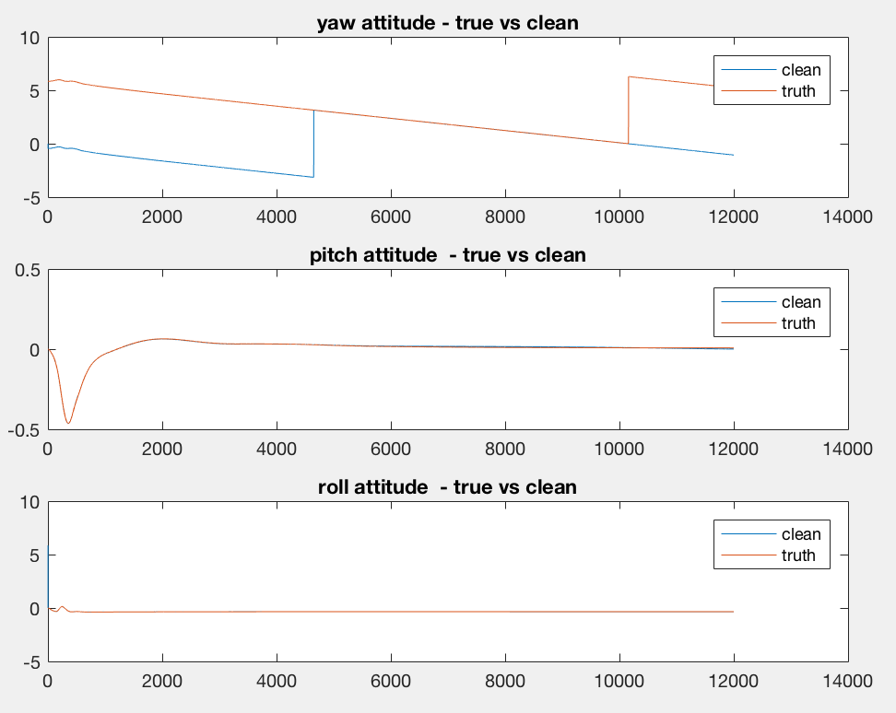

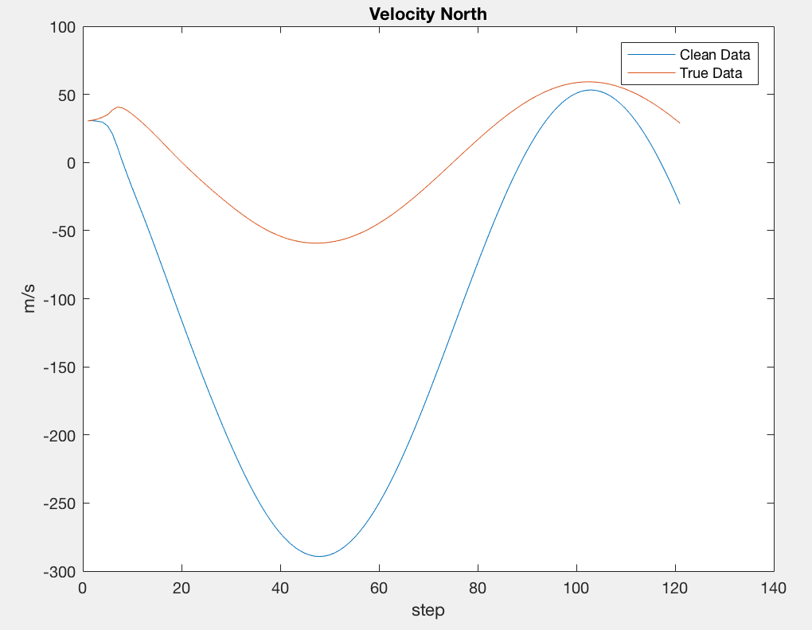

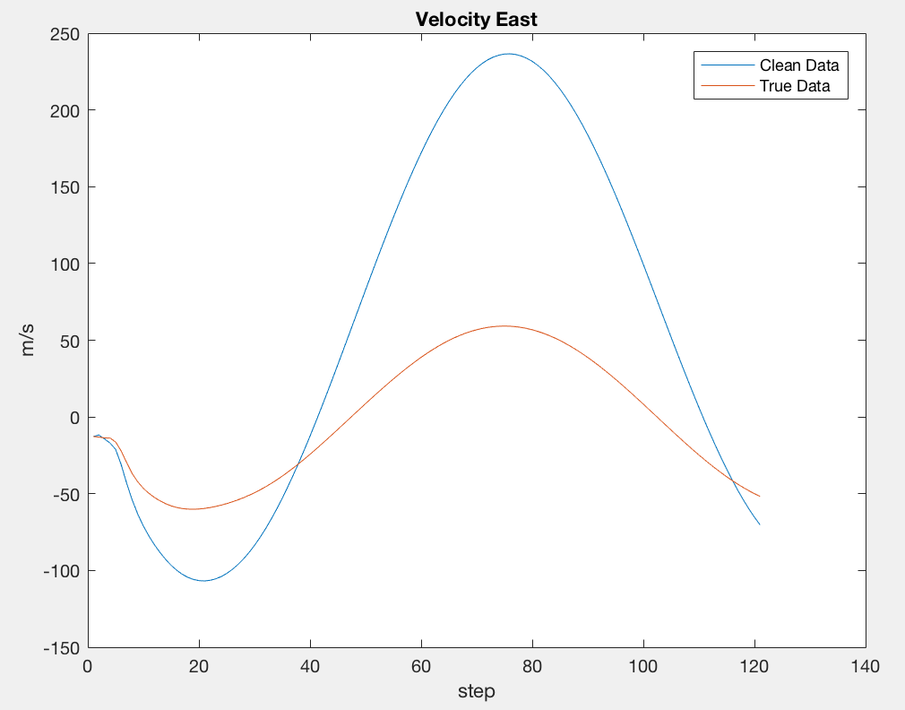

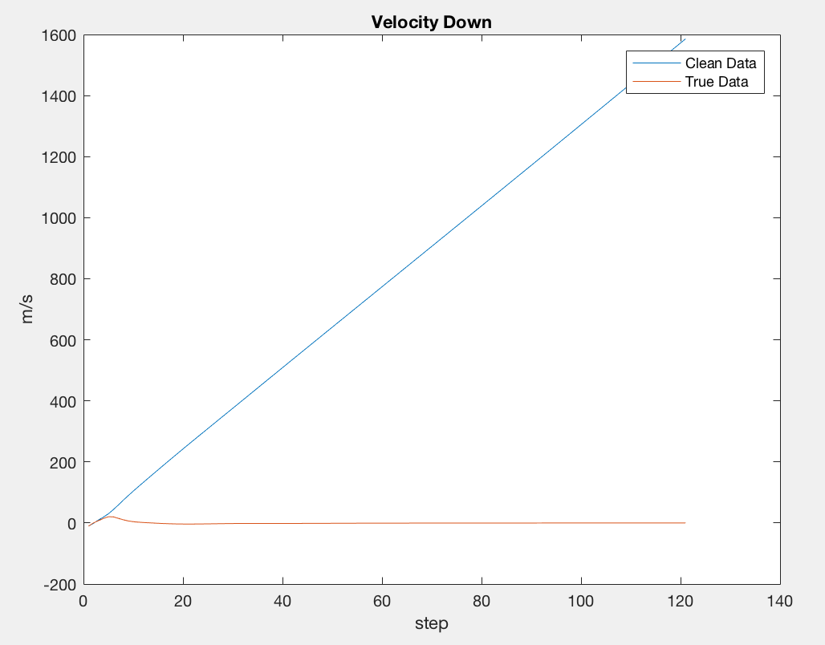

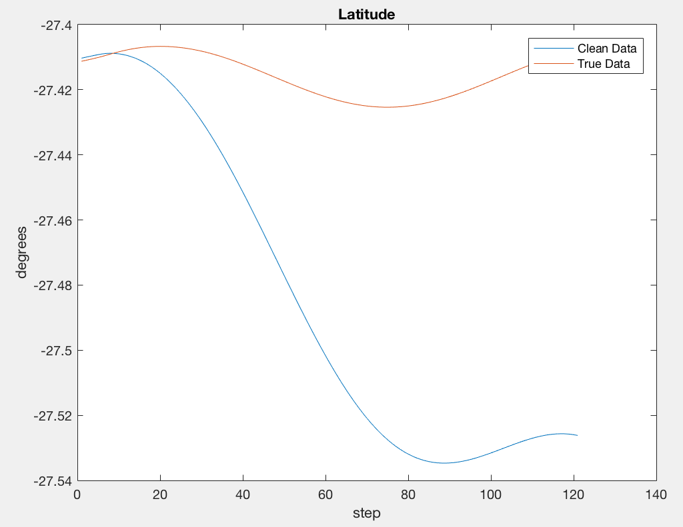

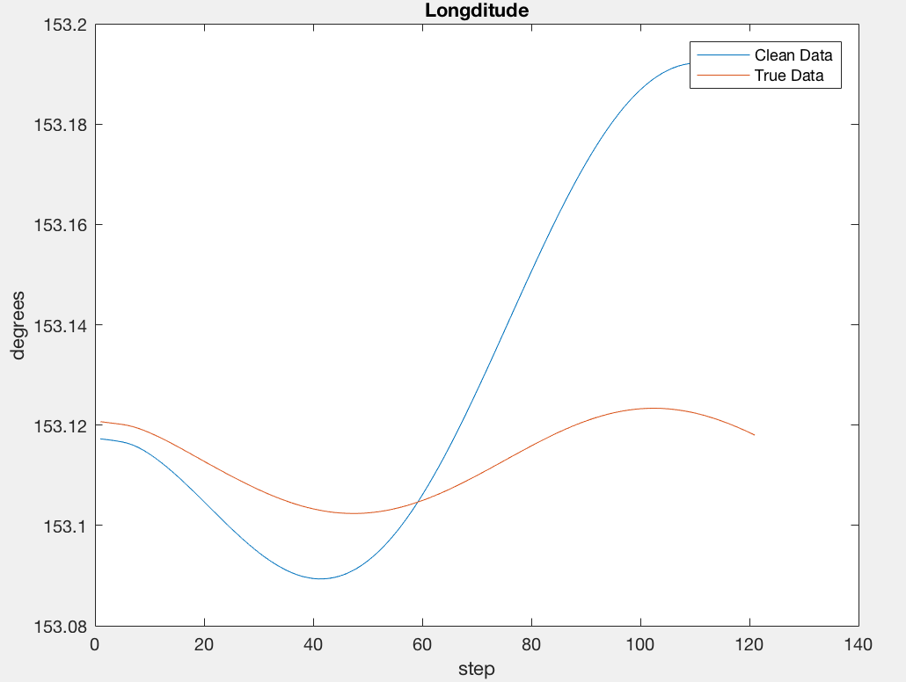

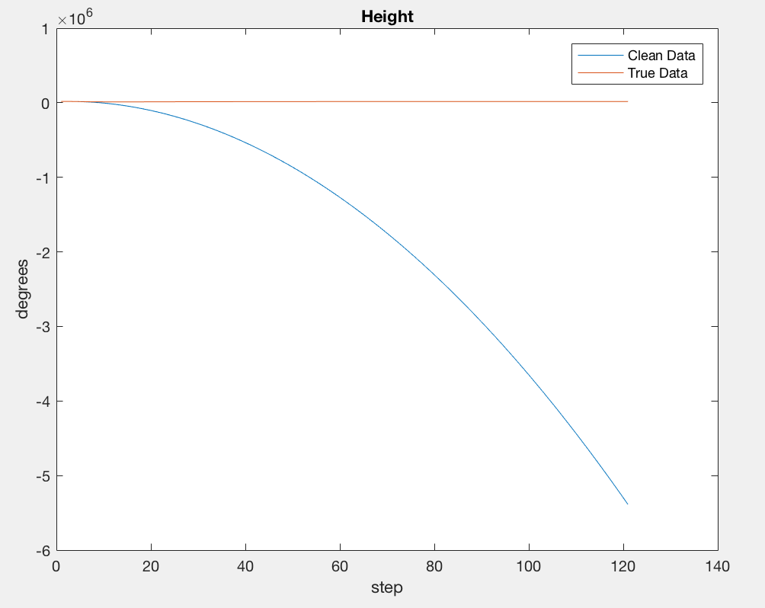

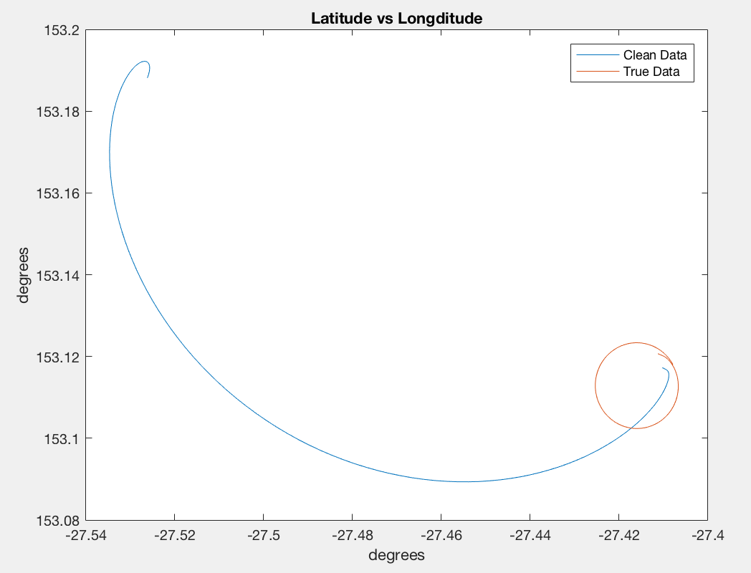

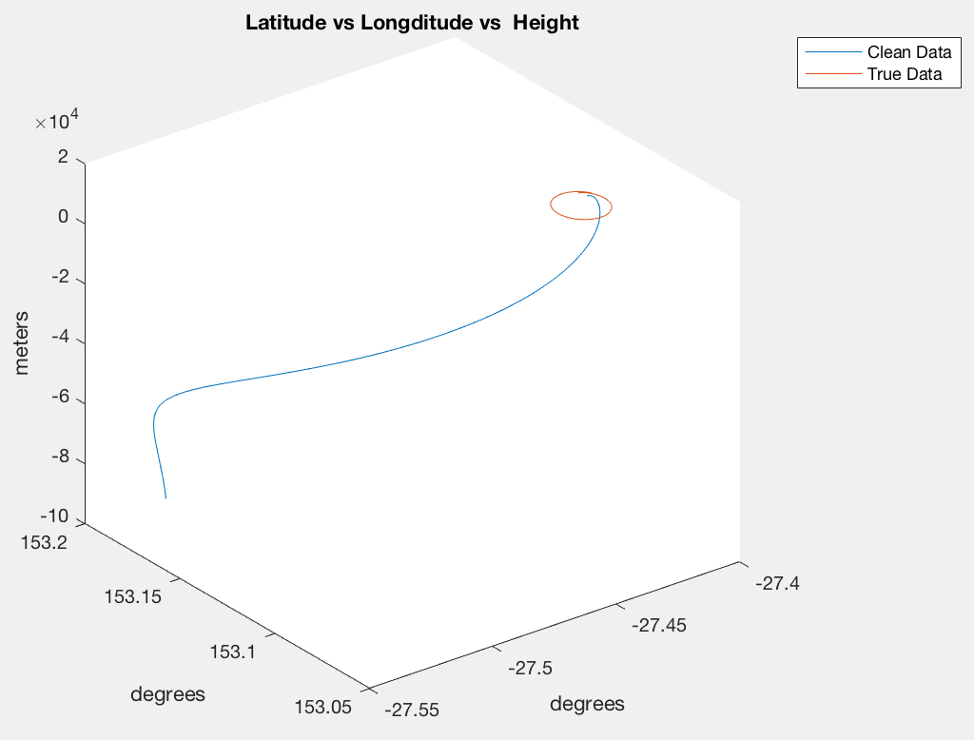

**8. Repeat for “noisy” data, and plot comparisons.**

Due to an error that cannot be debugged, the velocity parts for noisy data were exactly the same as the clean data except for the attitude data. As observed the data were still close but not as close as the clean data.

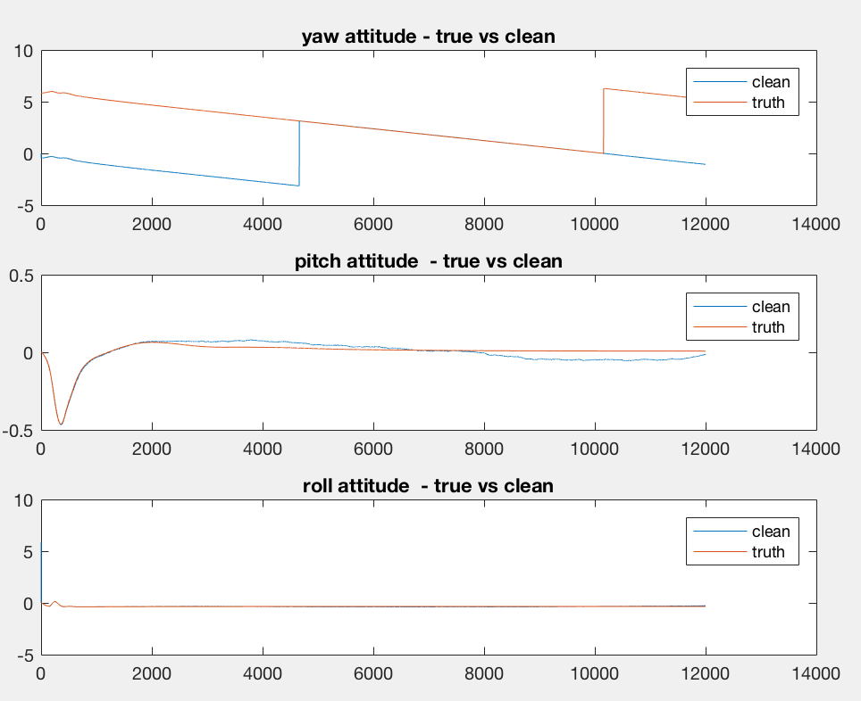

**9. Make some comments about the above comparisons**

The shape of the plots provided for position and velocity part were not expected. As instructed I merged the two labs INS1 and INS2 for loops together but probably due to some error on the code maybe the some of the formulas were stagnant in the loop and not used to update other formulas. However, I will comment on the expected observations.

The expected observation was that the clean data of latitude and longitude were supposed to be closer and more accurate, forming like a parallel line with the truth data having the same shape as the clean and noisy data. The height however was expected to have and increase in error as the number of steps increases. This was the same for noisy longitude and latitude as they have the same shape but the error increases as the step increases.

The shape of the estimated data resembles similarly to the true data. However, the data is slightly off. This can be explained by issues of accuracy from the manufacturer or the device not properly calibrated. All inertial navigation systems suffer from integration drift: small errors in the measurement of acceleration and angular velocity are integrated into progressively larger errors in velocity, which are compounded into still greater errors in position. Since the new position is calculated from the previous calculated position and the measured acceleration and angular velocity, these errors accumulate roughly proportionally to the time since the initial position was input. Therefore, the position must be periodically corrected by input from some other type of navigation system.

Improvements to the estimated data can be made by combining a few other techniques like the Kalman fliter to produce a more corrected estimate of the data.

Some improvements on the yaw attitude data can be made by trying to manipulate the clean and noisy data to fit the truth data by shifting the period and possibly the phase. This can be done by adding 2*pi to yaw to match the sensors data to the truth.